CI/CD PIPELINE WITH DOCKER, JENKINS, AND AWS
GitHub Link: https://github.com/vishalinirajika-v/devops-build
Deployed Site URL: http://13.233.64.141

PROJECT OVERVIEW
This project demonstrates a complete CI/CD pipeline for deploying a React application using modern DevOps tools and practices. The pipeline automates the Code integration, Docker image build, Image push to Docker Hub, Application deployment on AWS EC2, Monitoring and alerting setup.
OBJECTIVE
The primary objective of this project is to:
• Deploy a React application in a production-ready environment on AWS EC2
• Implement containerization using Docker for efficient application packaging
• Set up a CI/CD pipeline using Jenkins for automated build and deployment
• Use Docker Hub as a container registry for storing images
• Implement branch-based deployment strategy (dev & prod environments)
• Automate application deployment using Docker Compose
• Enable monitoring using Prometheus and Grafana
• Configure alerting to detect application downtime

STEPS COVERED
• Clone Repository from GitHub
• Setup EC2 Instance and configure security groups
• Install and configure Docker and Jenkins on EC2
• Dockerize the React application using Dockerfile
• Create build and deployment scripts (build.sh & deploy.sh)
• Push Docker images to Docker Hub (dev & prod repositories)
• Setup Jenkins Multibranch Pipeline
• Configure CI/CD pipeline using Jenkinsfile
• Implement branch-based deployment (dev → dev repo, master → prod repo)
• Deploy application using Docker Compose
• Configure monitoring using Prometheus and Blackbox Exporter
• Visualize metrics and create alerts using Grafana
• Test application health and alert triggering
CREATION OF EC2
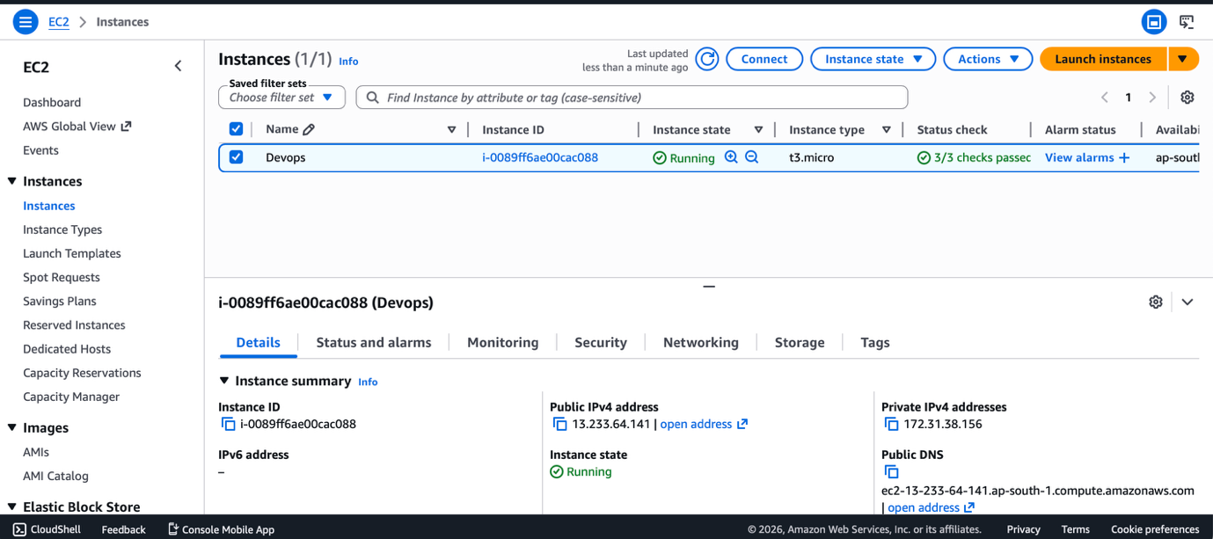
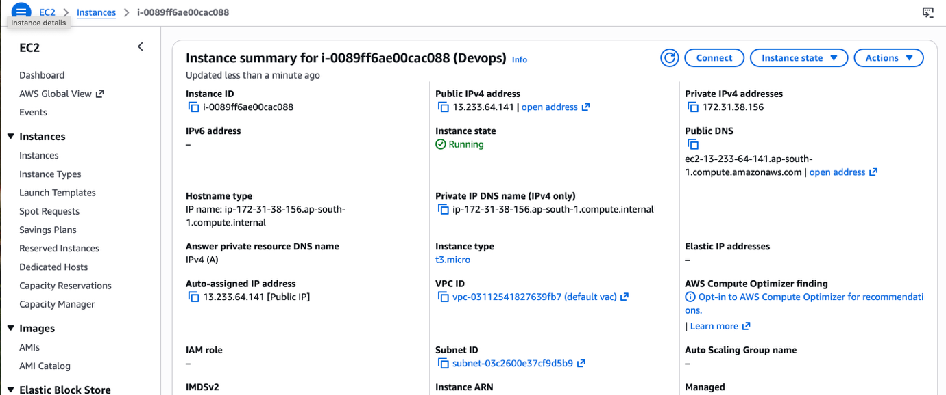
SECURITY GROUP CONFIGURATIONS
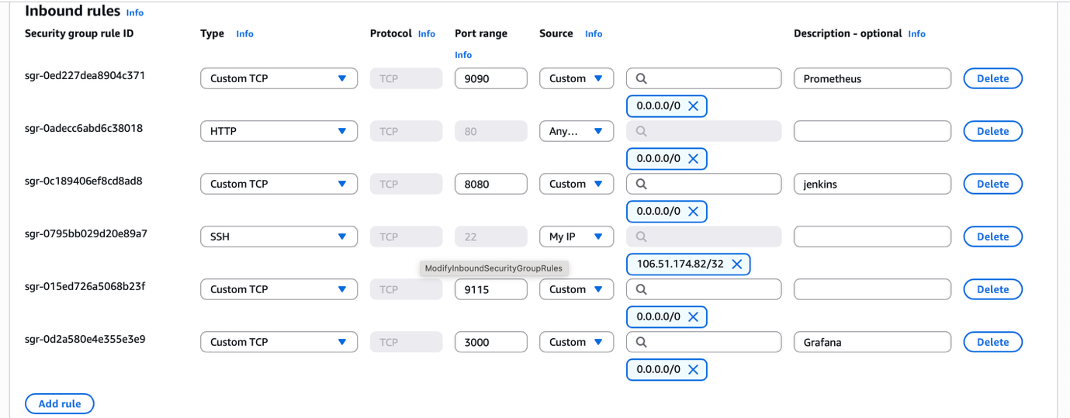

CLONING THE REPO AND INSTALLING REQUIRED TOOLS ON EC2
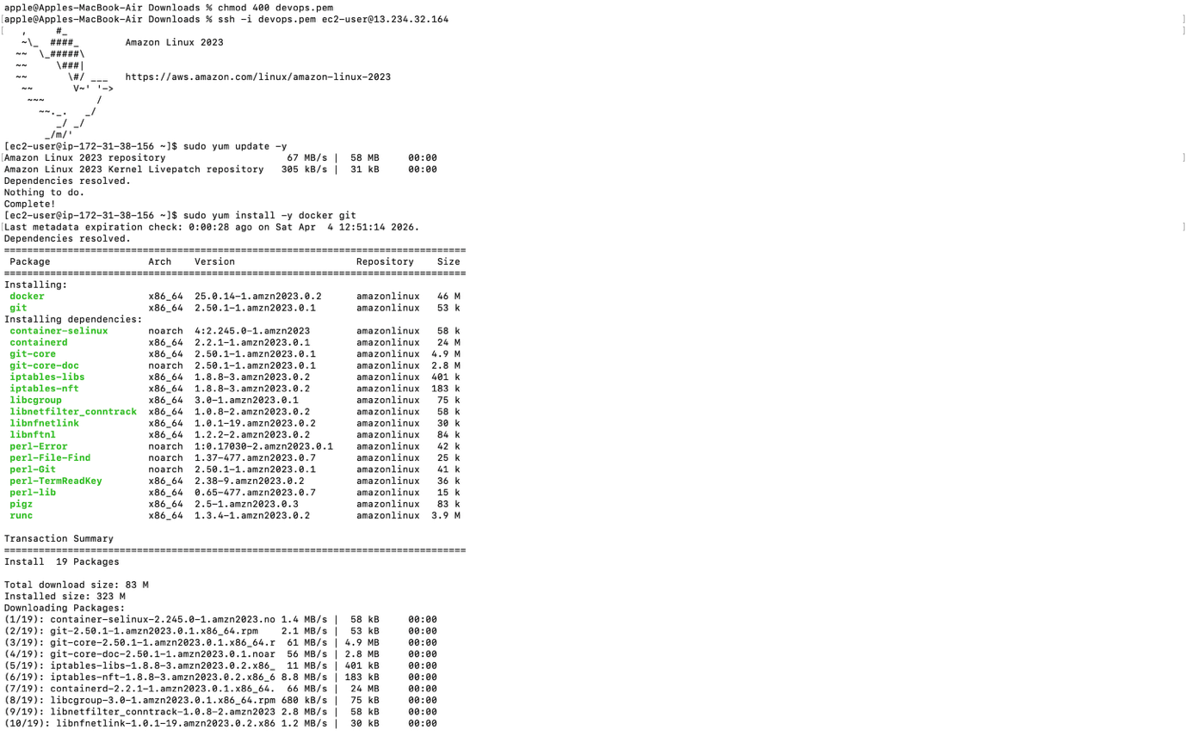
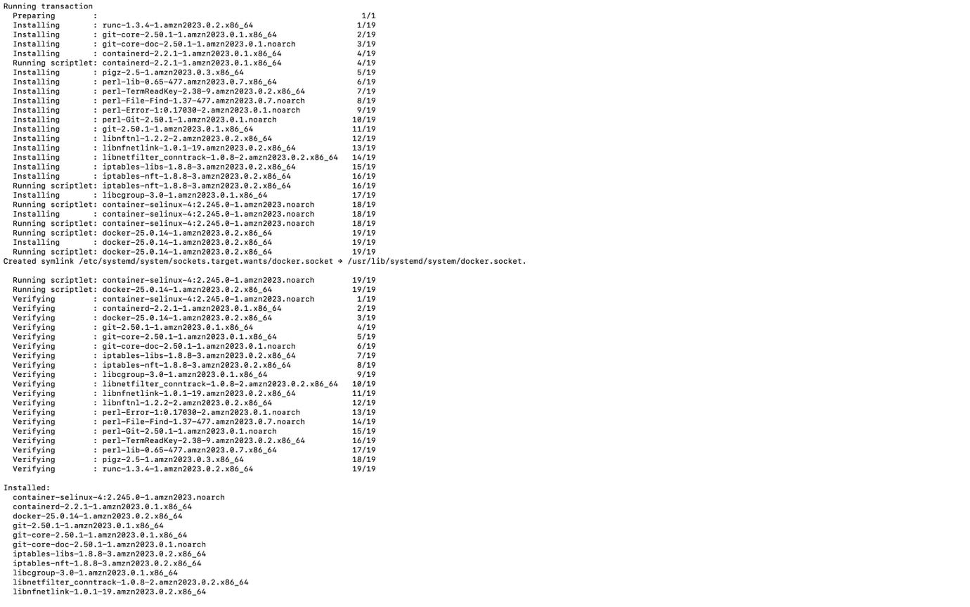
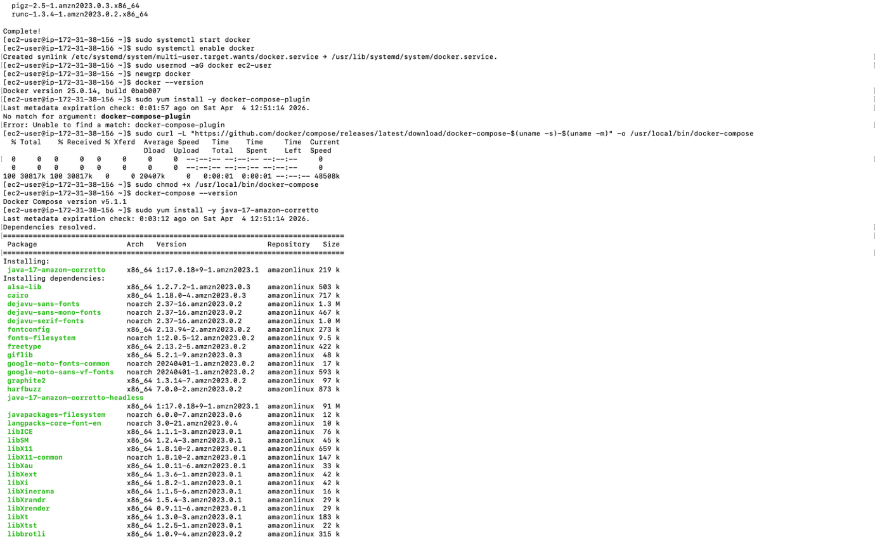
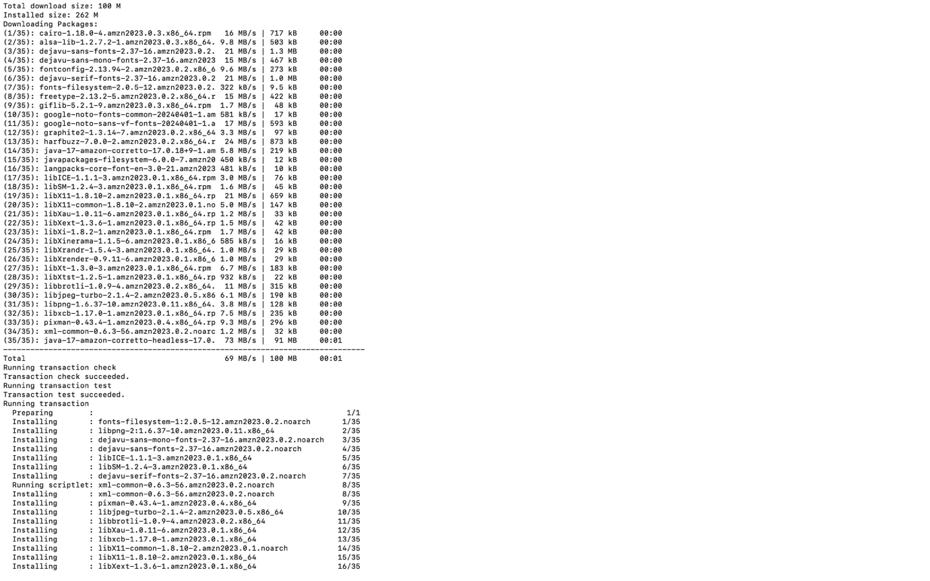
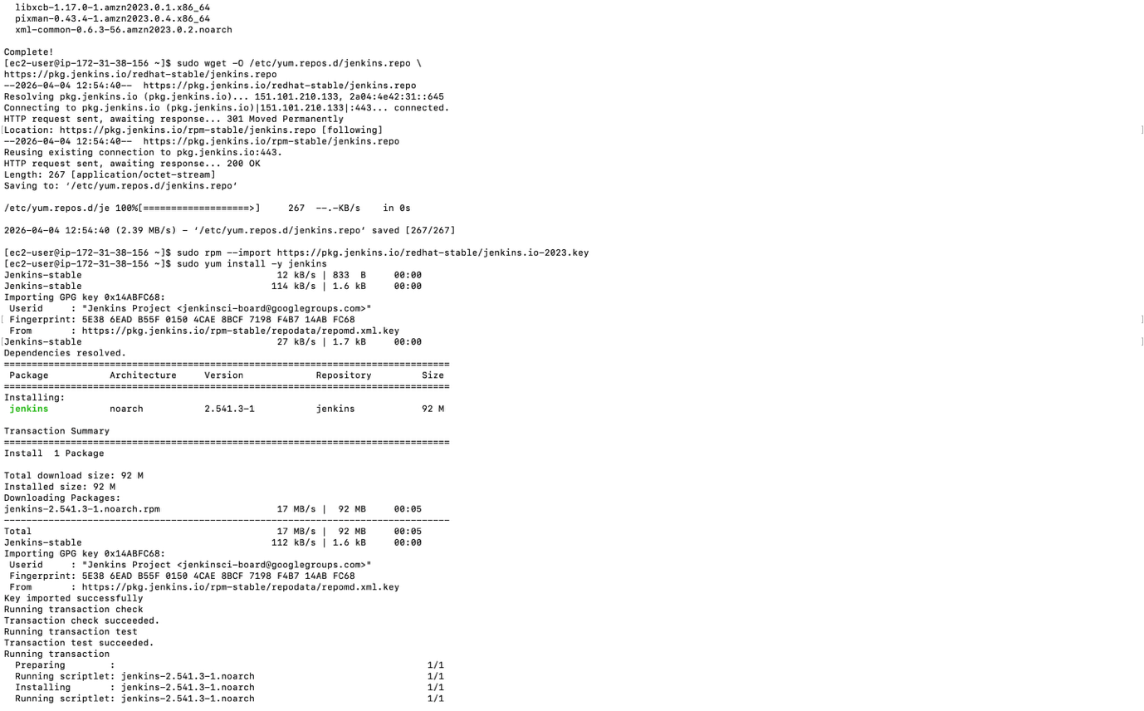
DOCKER
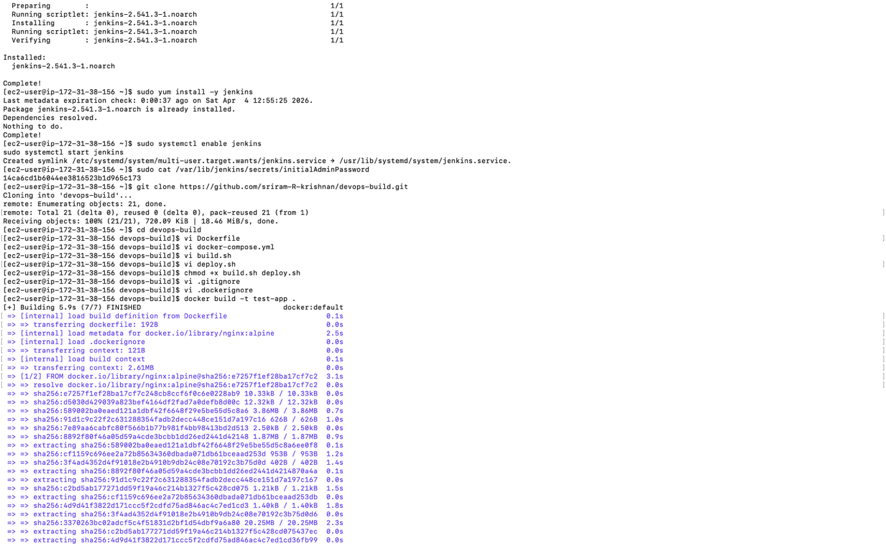
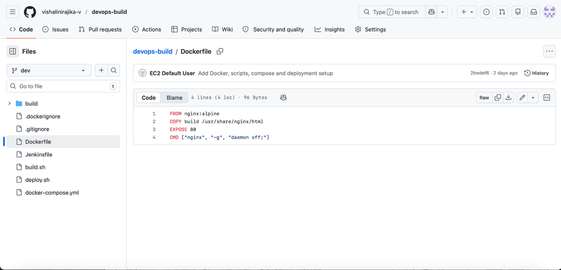
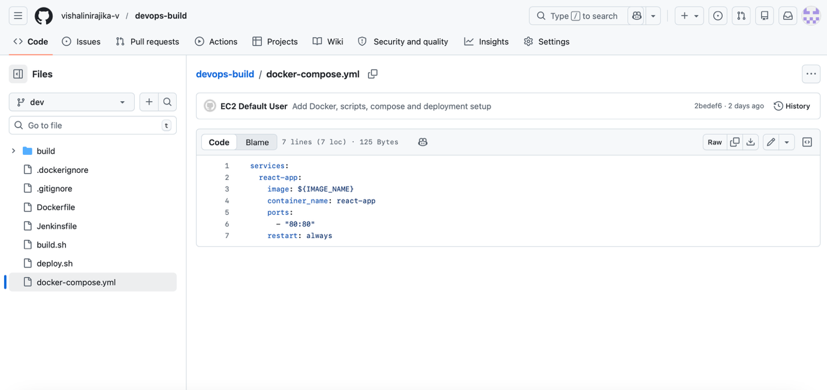

PUSHING THE CODE TO MY REPO
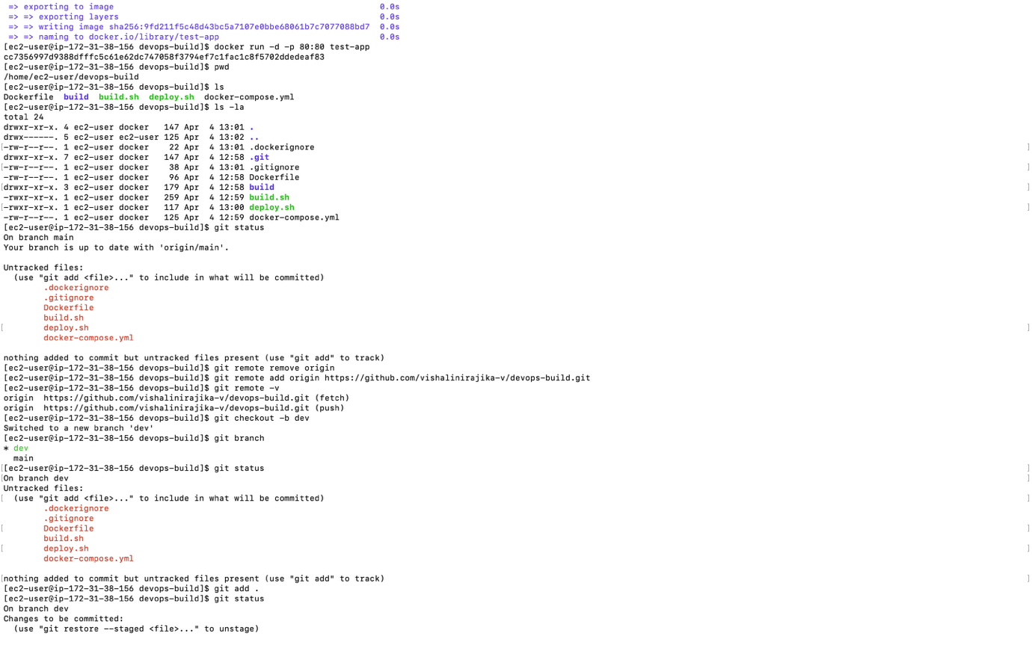
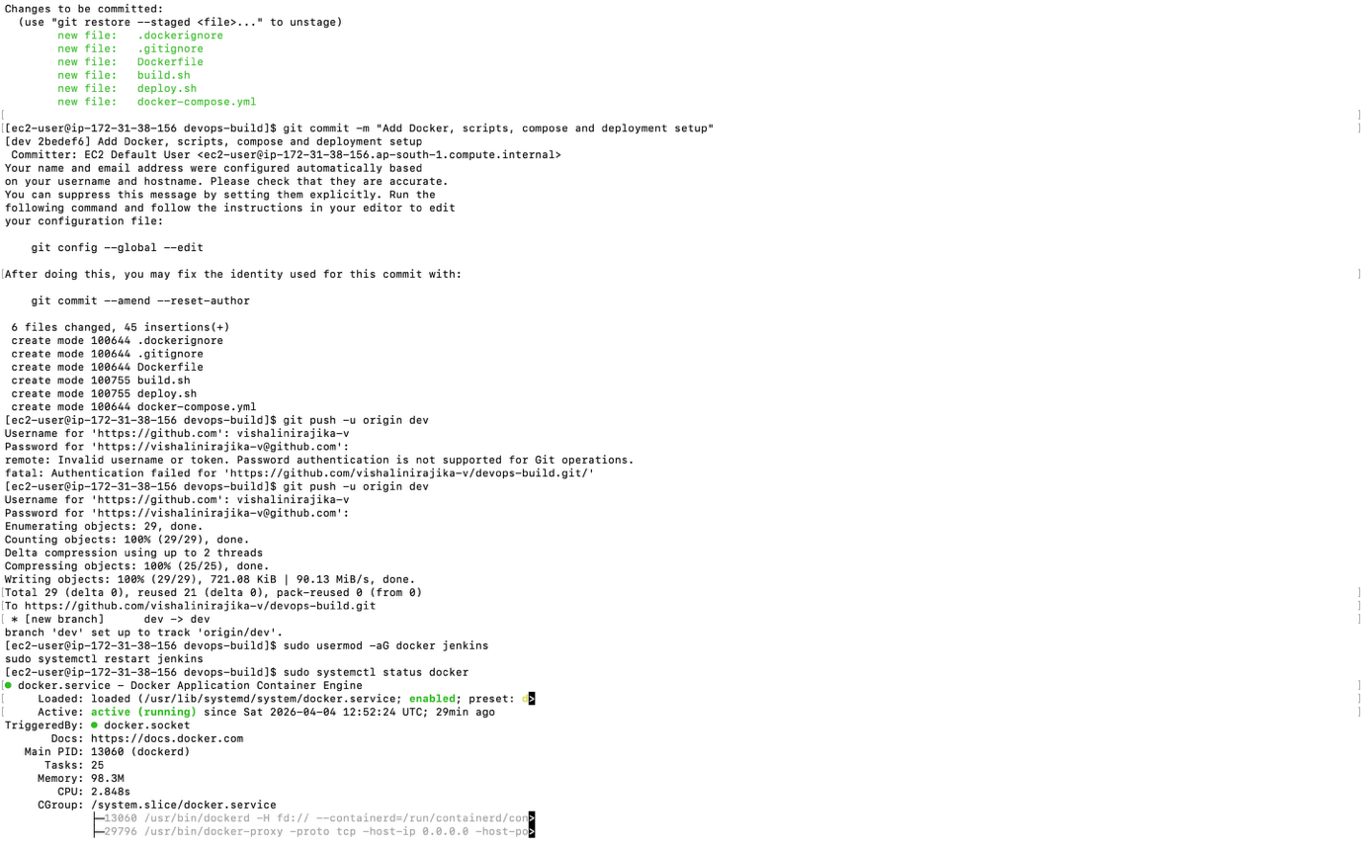

DOCKER IMAGES
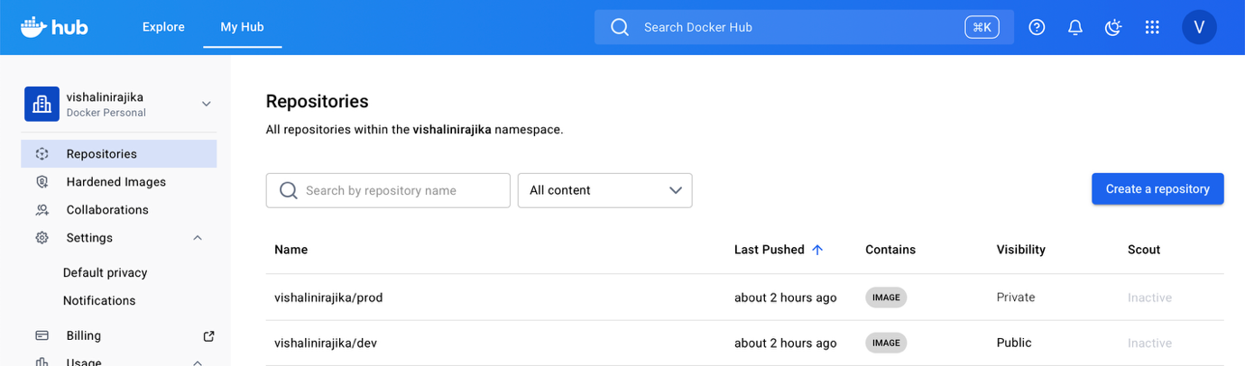
DOCKER HUB REPO WITH IMAGE TAGS
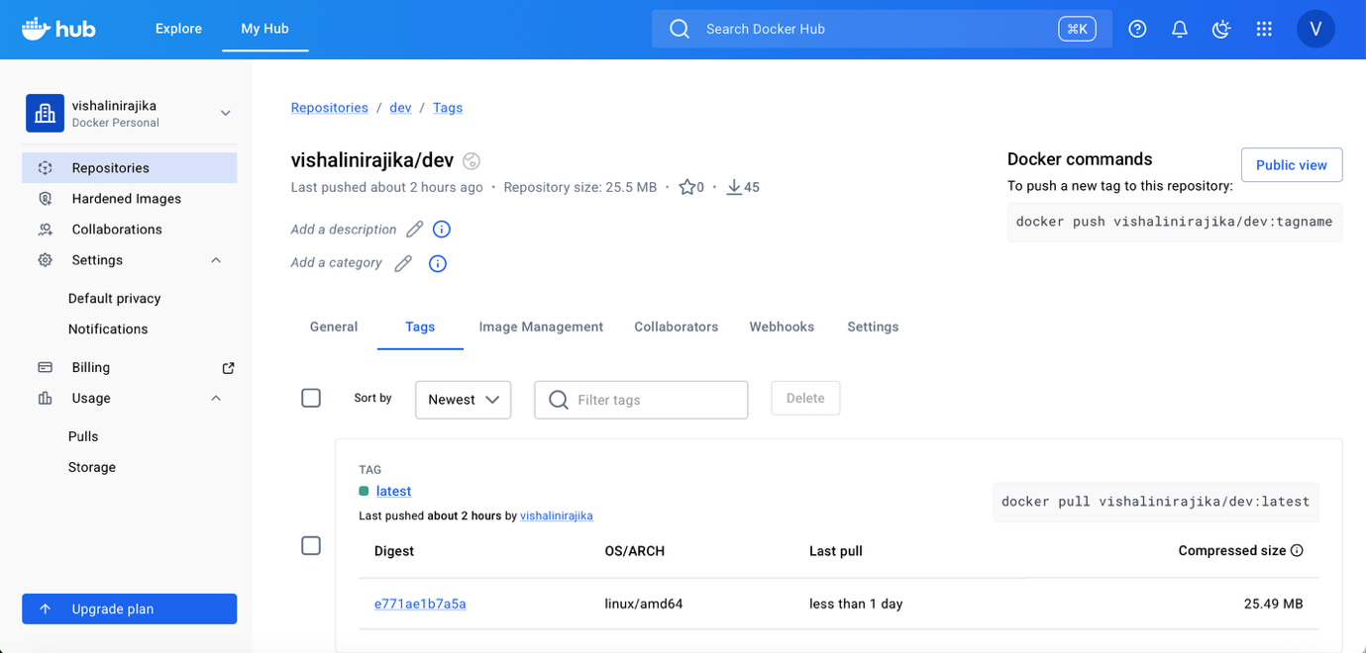
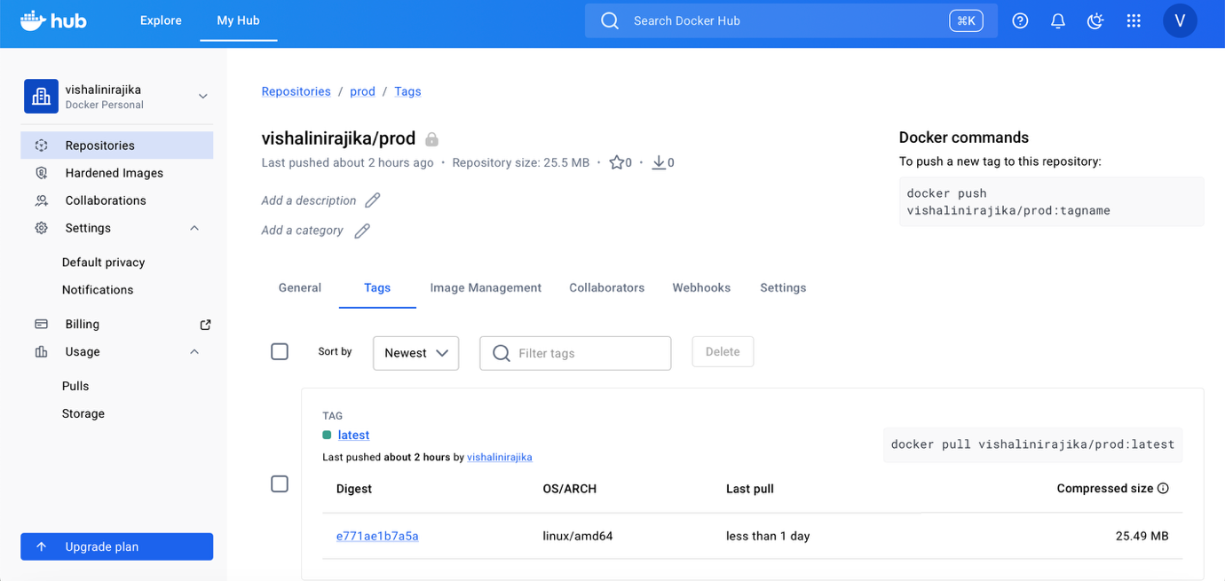

ACCESSING JENKINS THROUGH EC2 IP
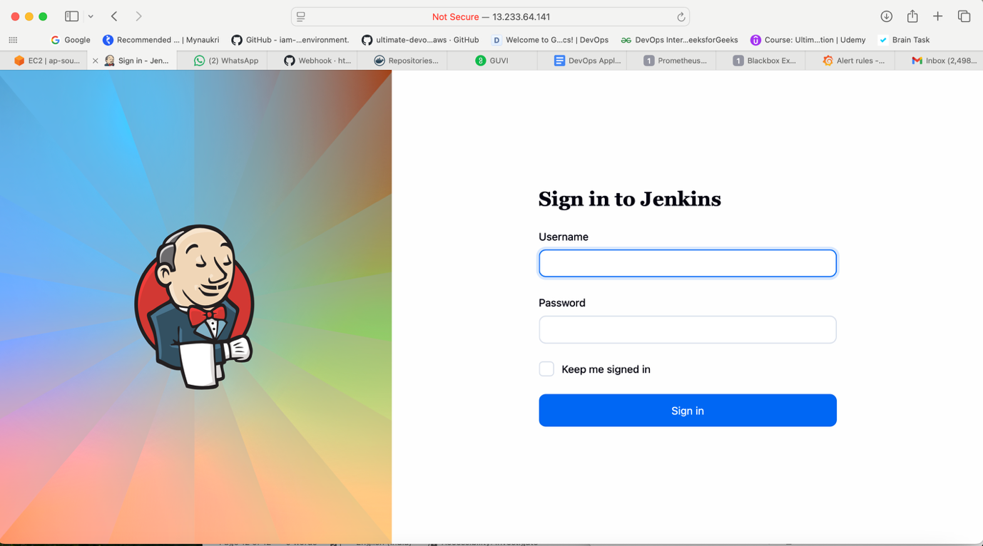
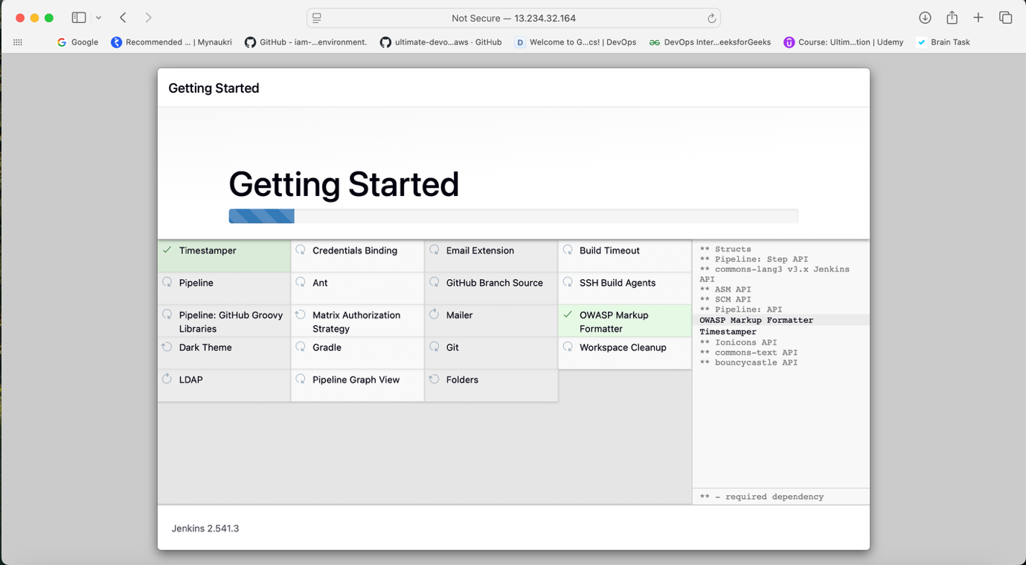

CREATION OF MULTIBRANCH PIPELINE
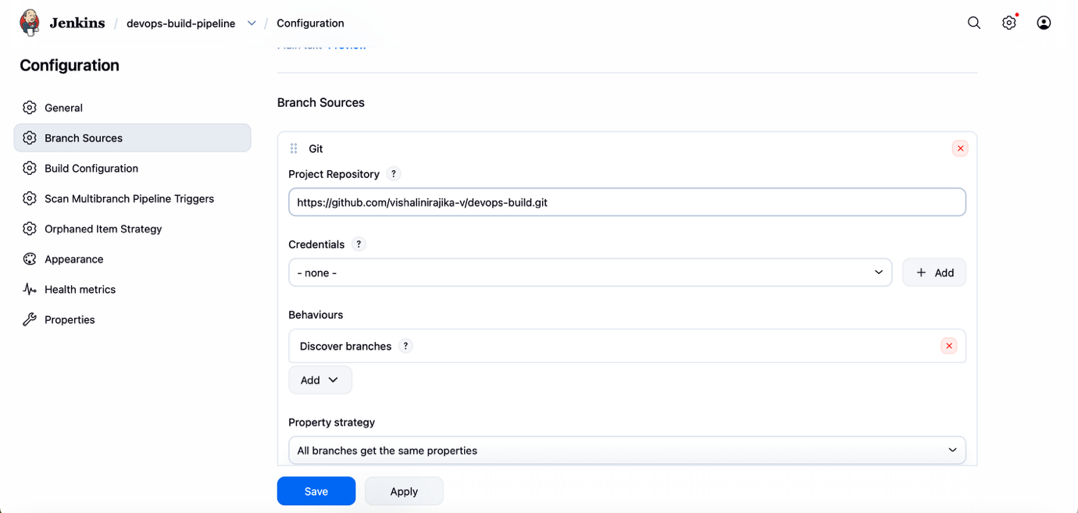
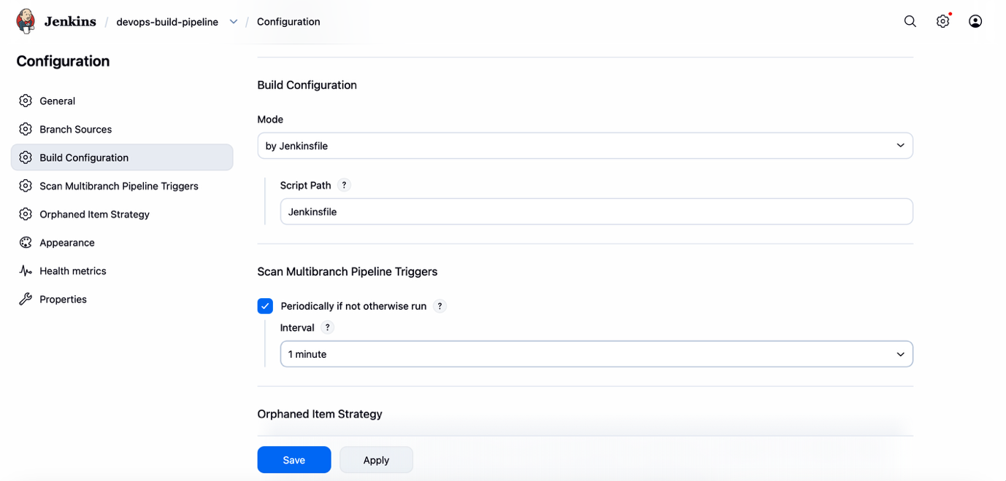
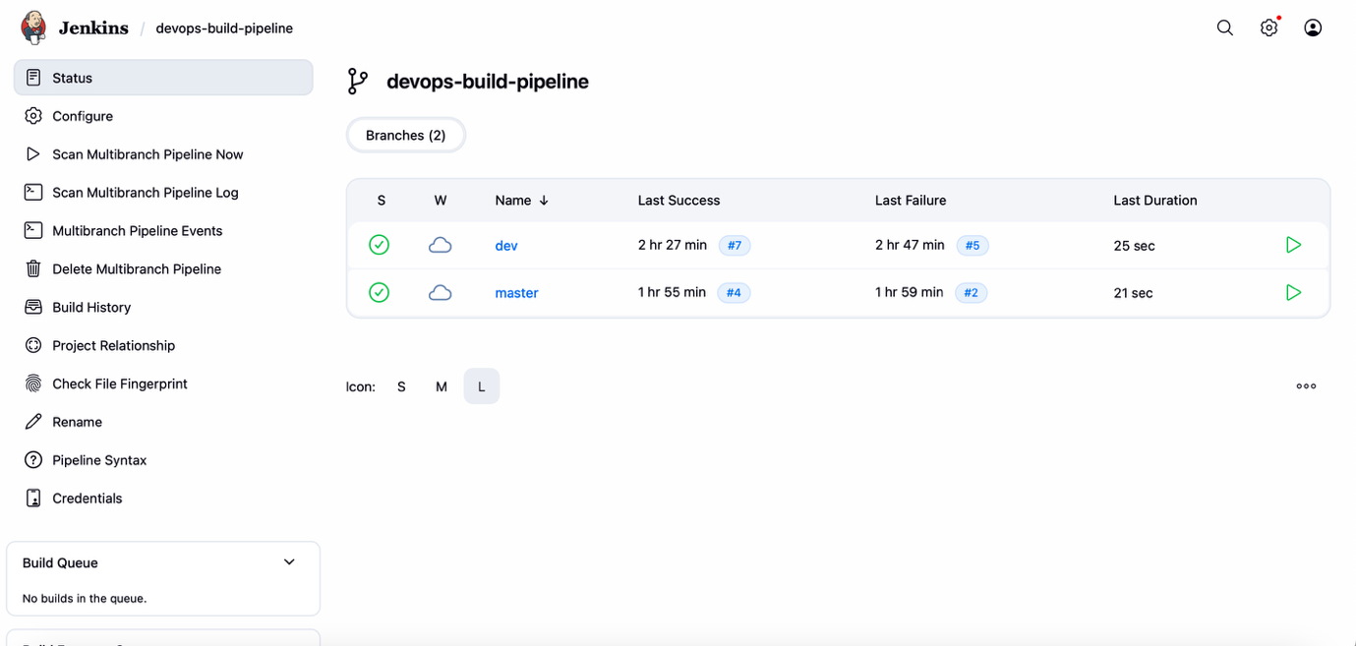
ADDING CREDENTIAL TO ACCESS THE DOCKERHUB
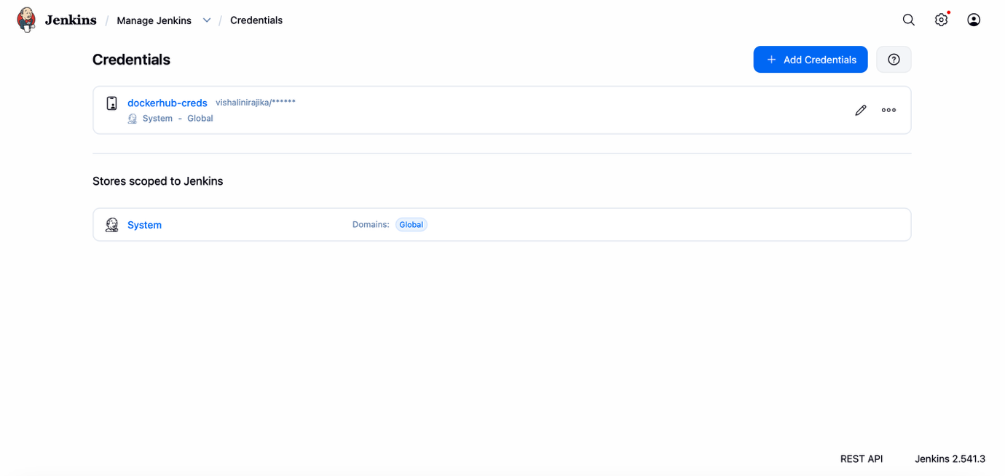
WEBHOOK CONFIGURATION
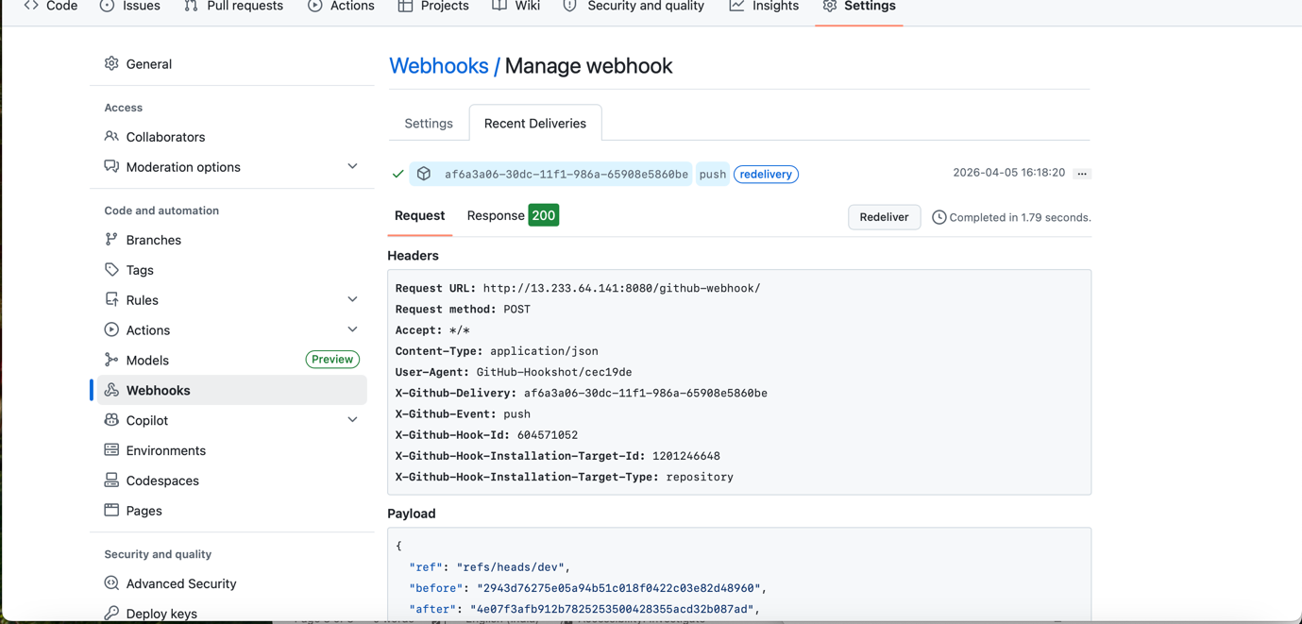
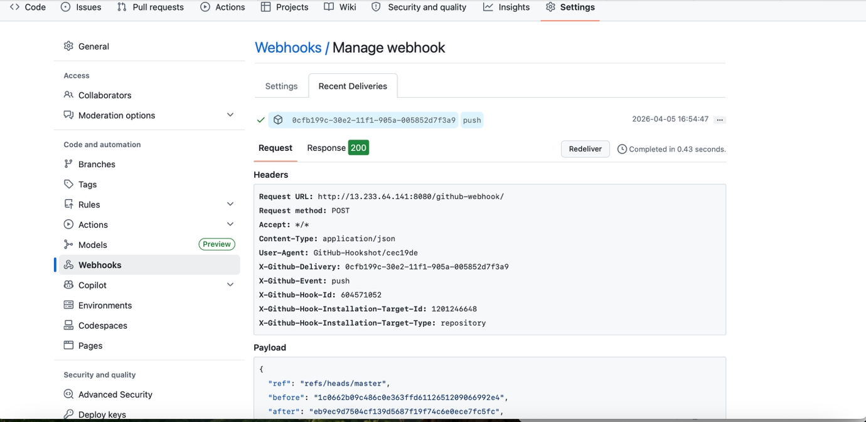
PUSHING COMMIT TO TRIGGER THE PIPELINE
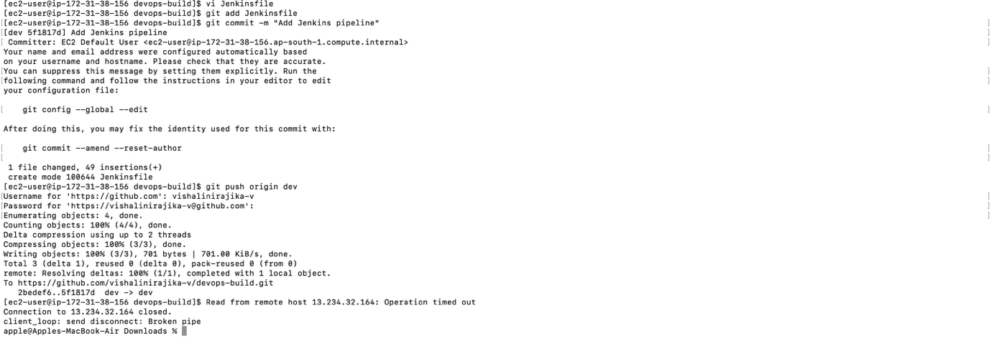
DEV
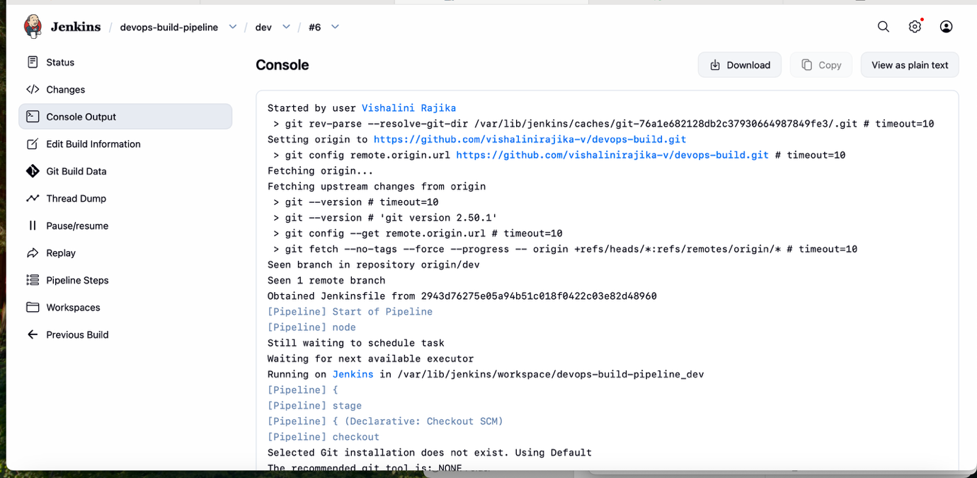
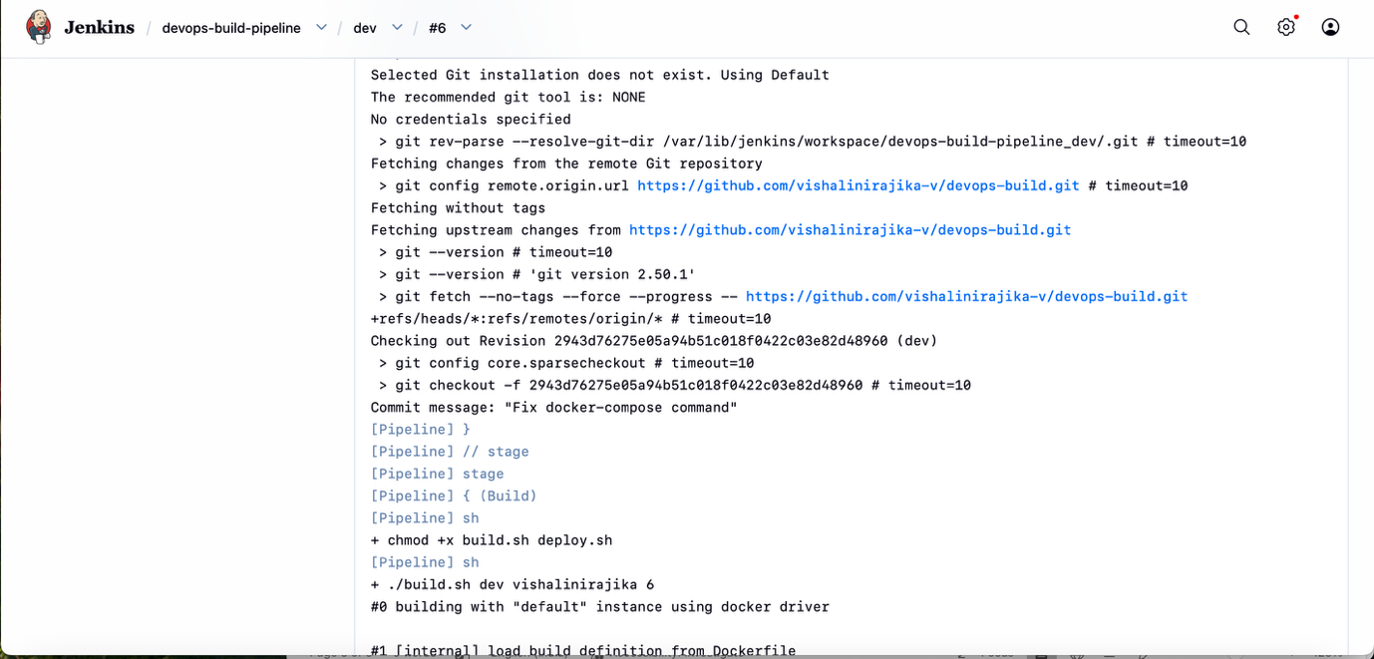
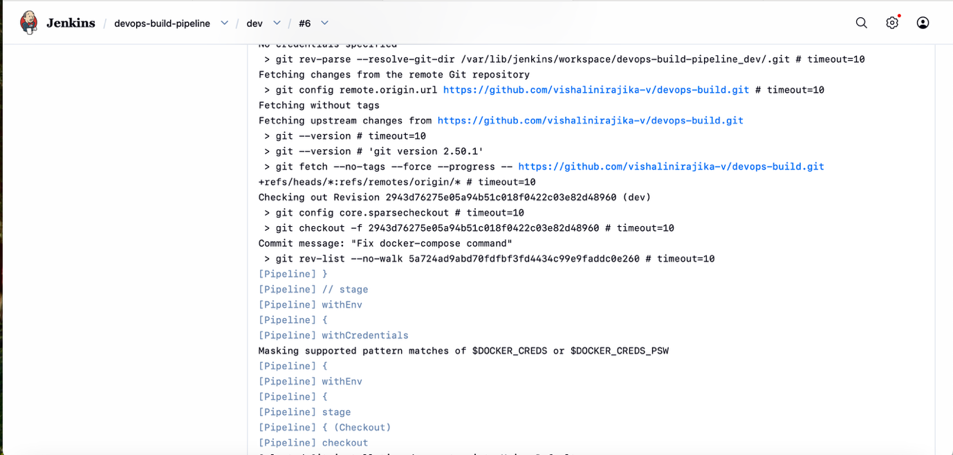
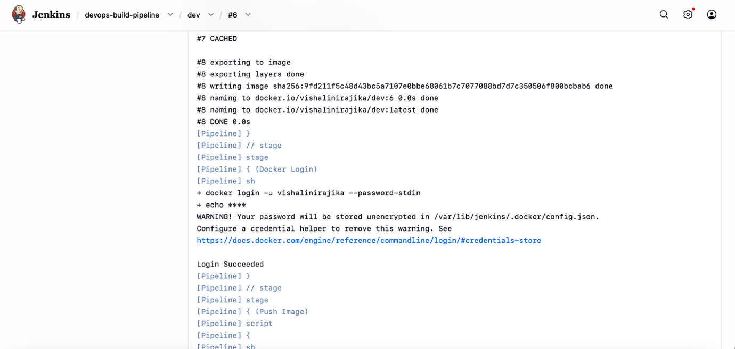
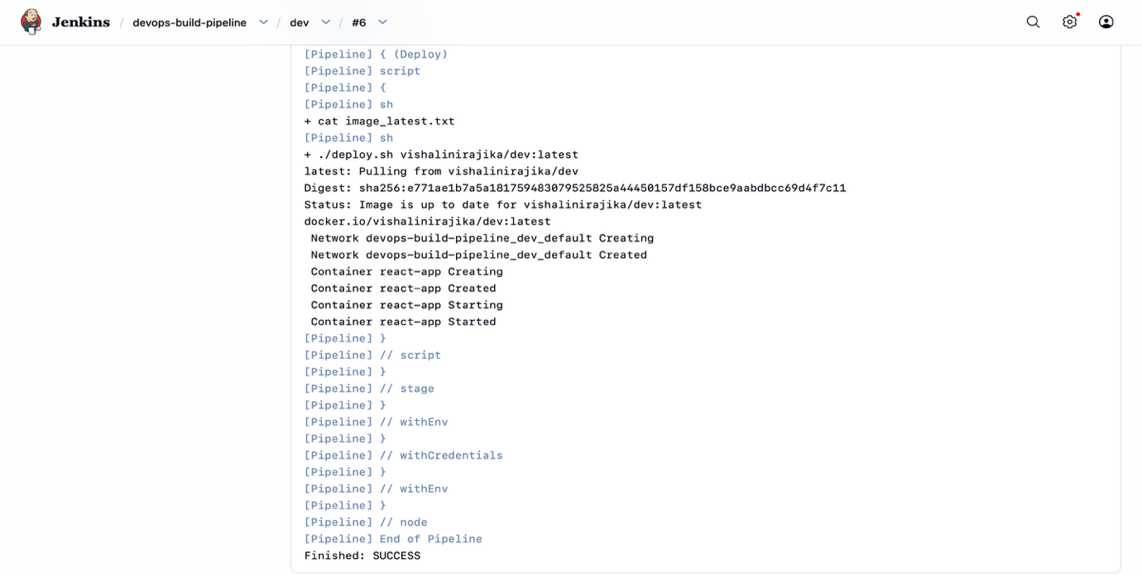
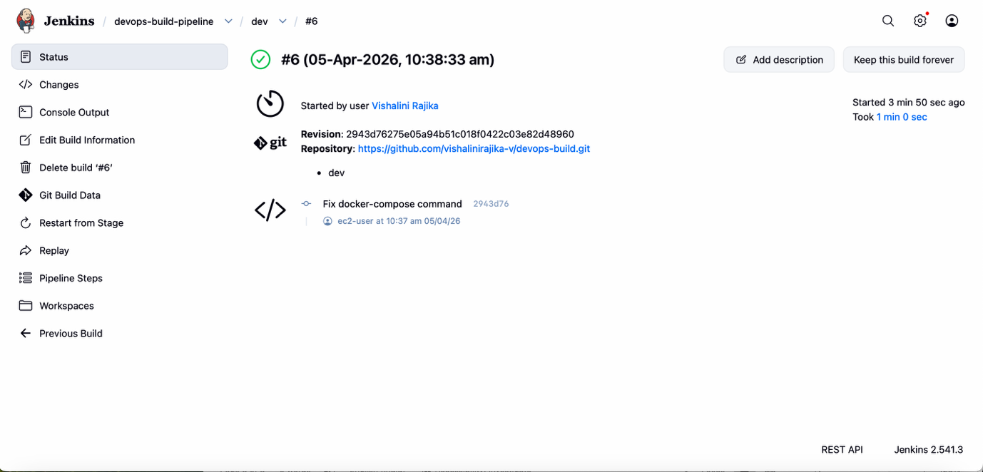
MASTER
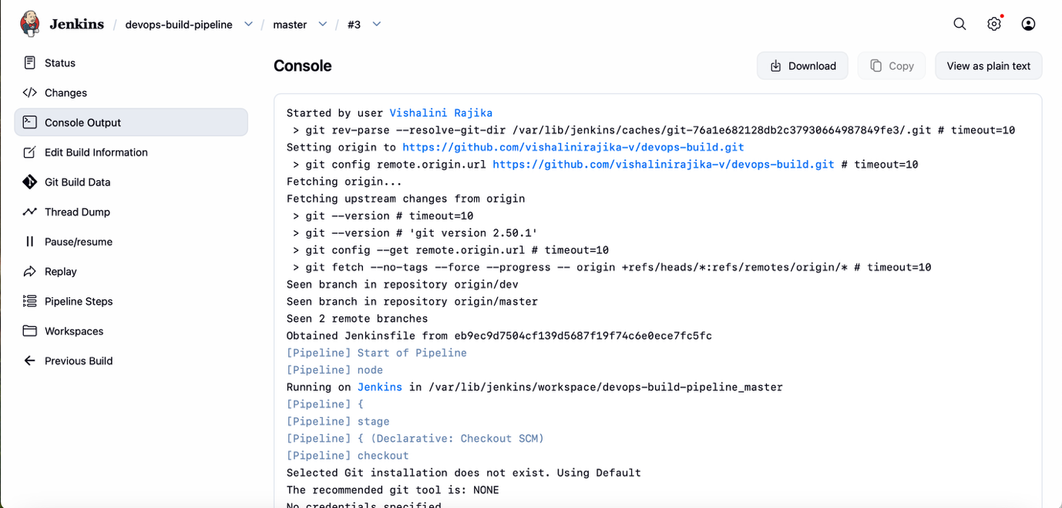
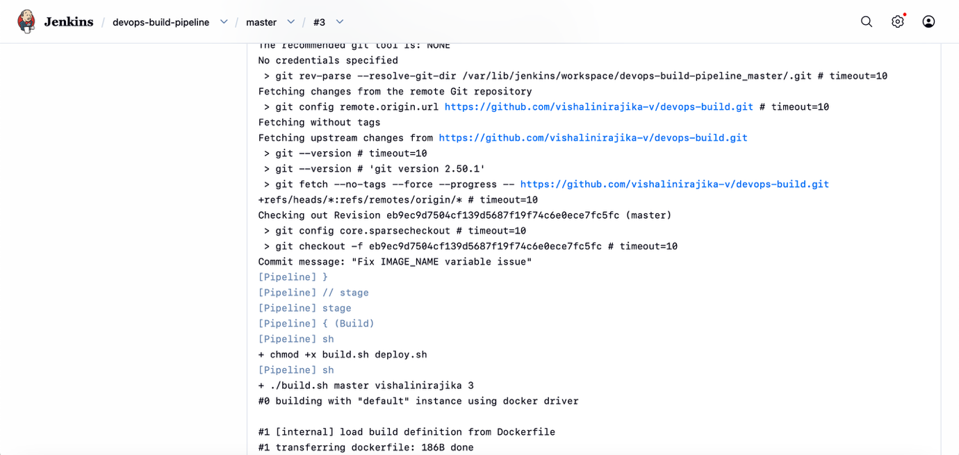
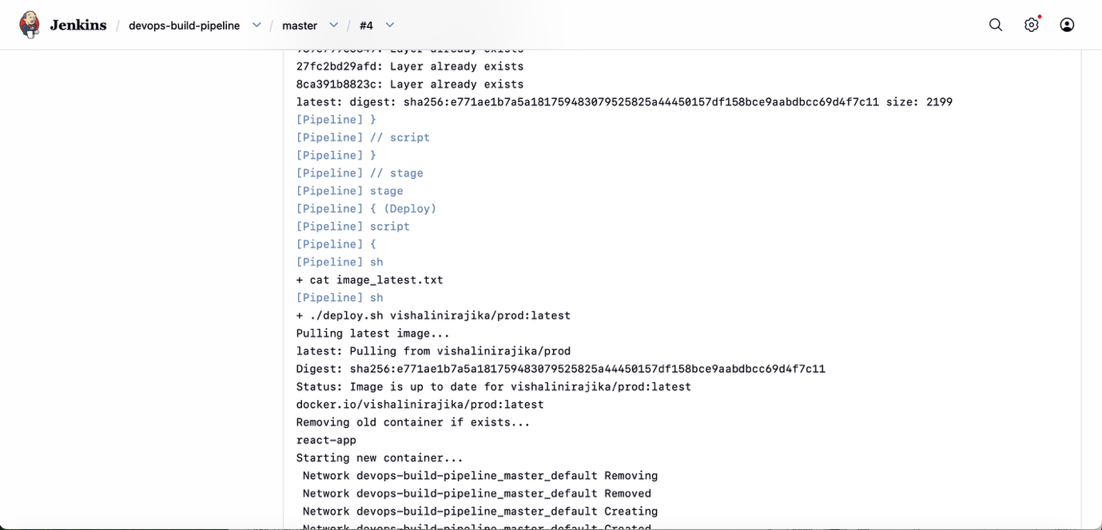
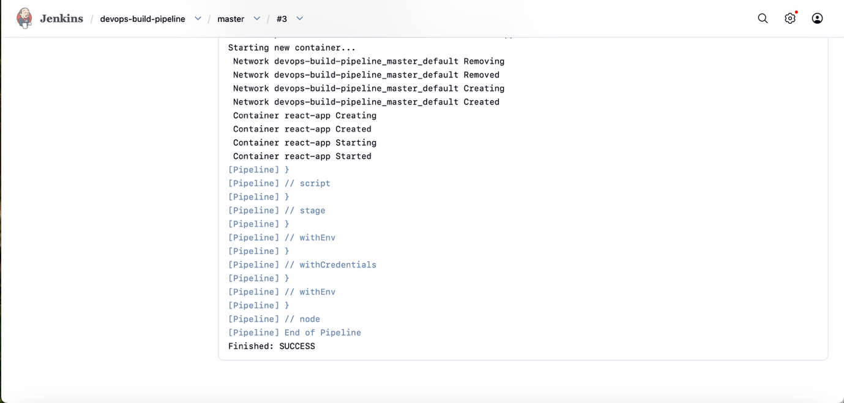
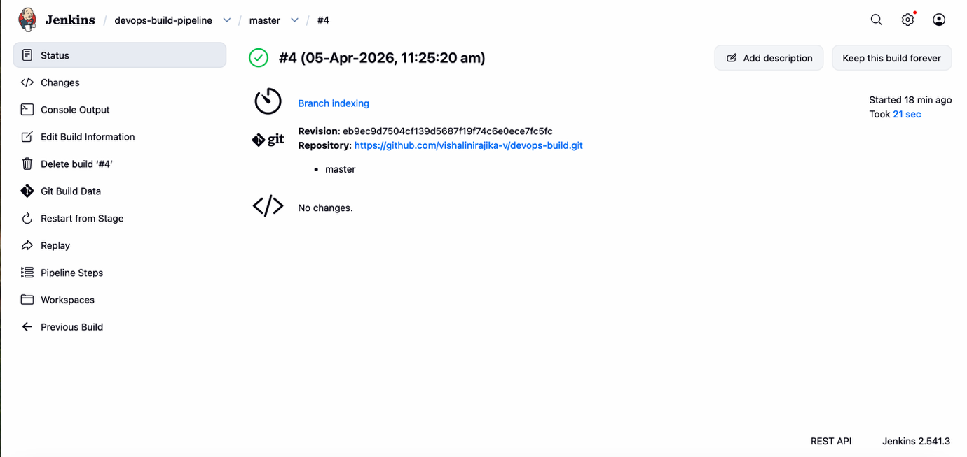
DEPLOYED SITE PAGE
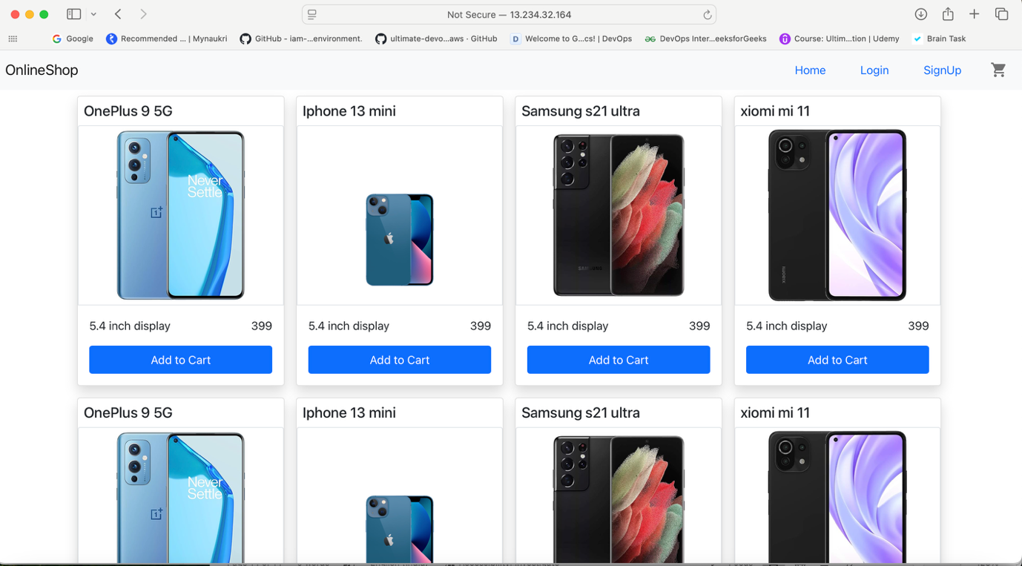

MONITORING AND ALERTING
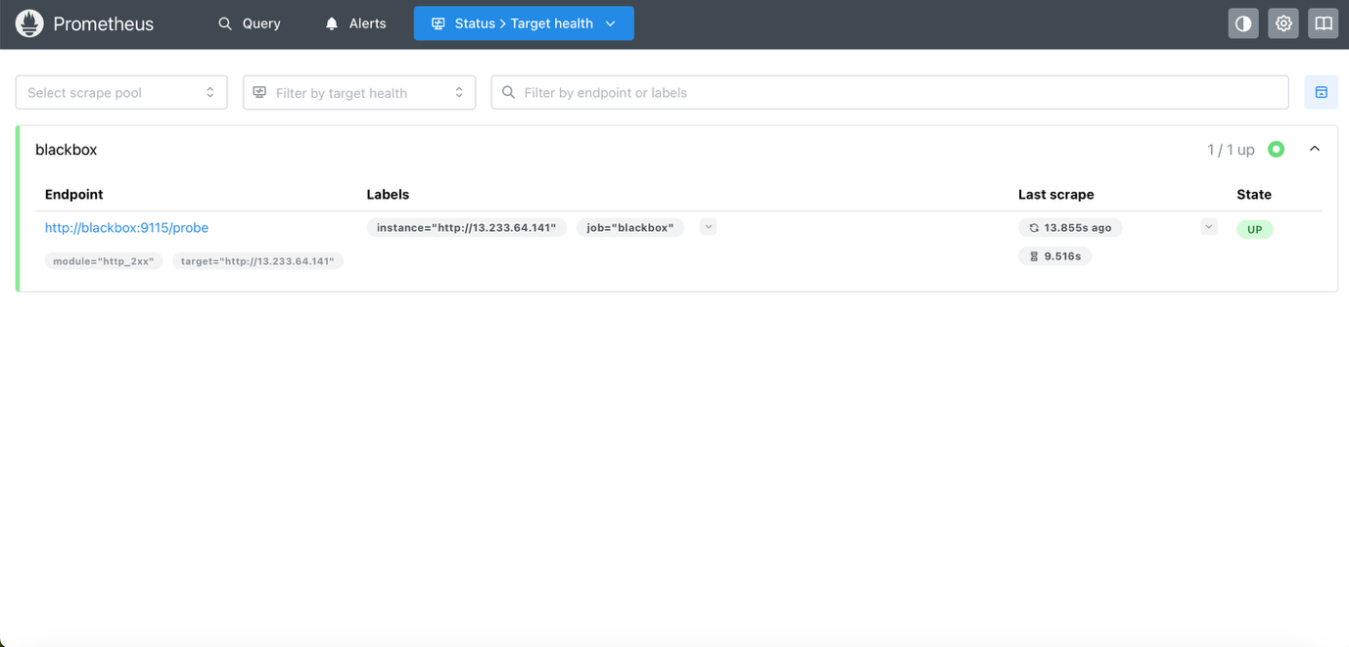
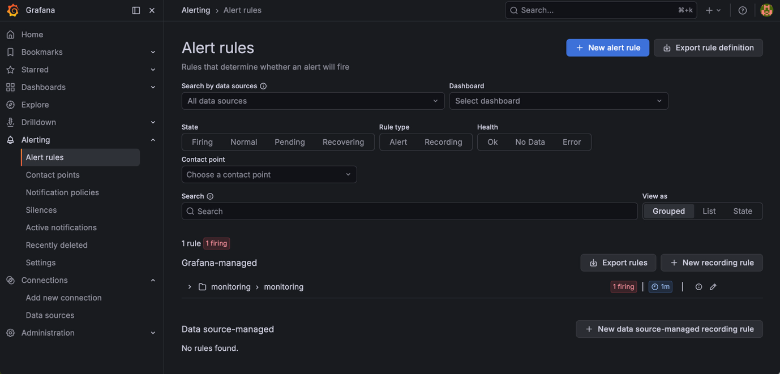
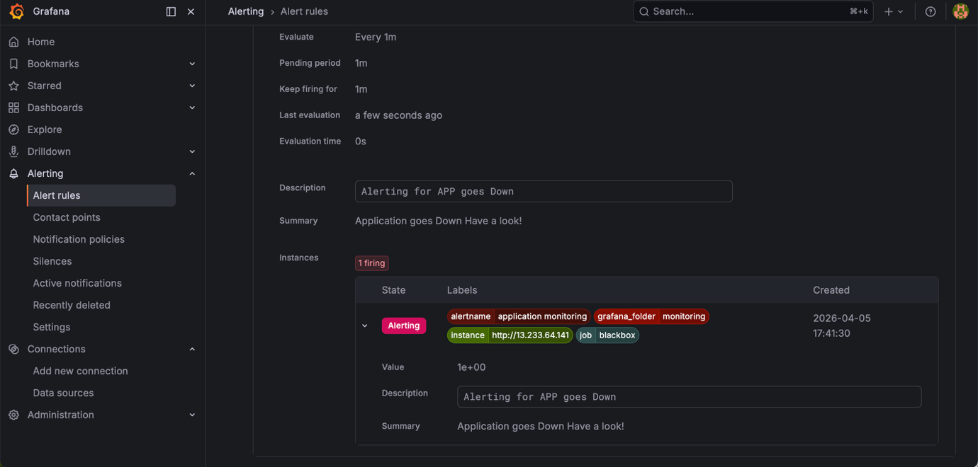
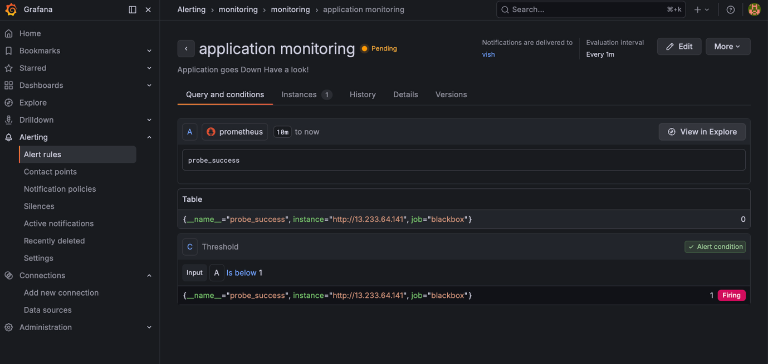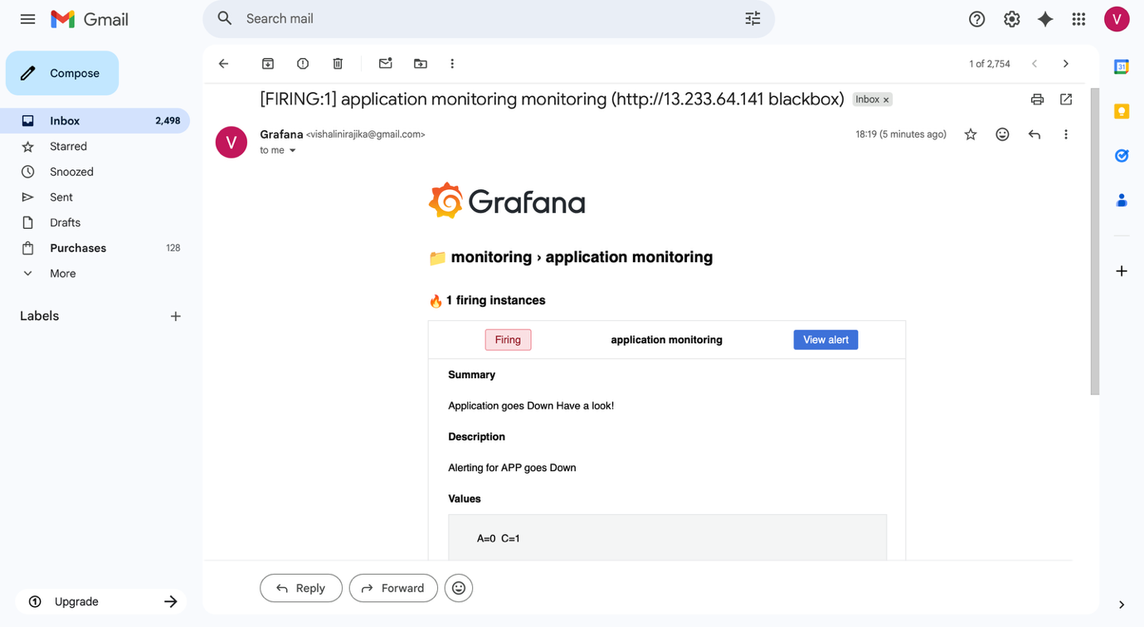
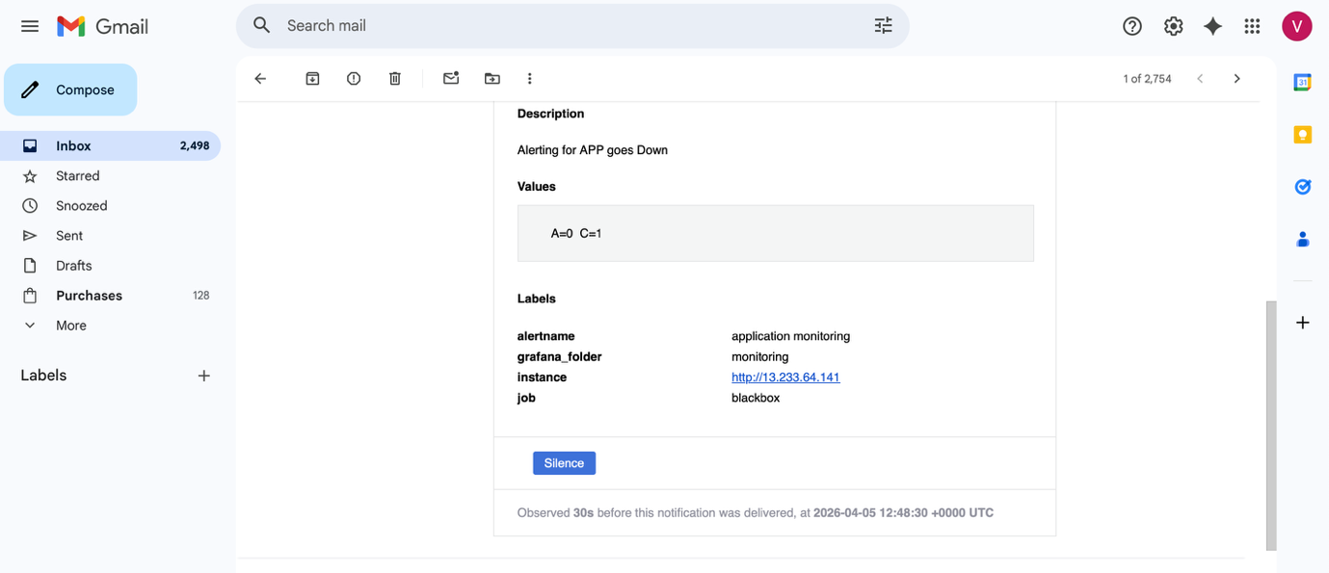
CONCLUSION
The project successfully demonstrates an end-to-end DevOps pipeline including:
- Automated build and deployment
- Containerized architecture

